The number of tourists visiting Malaysia and Dubai from 1995 to 2003 is presented below.

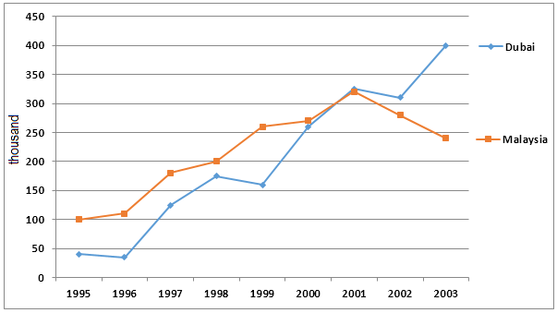

The line graph provides information about number of tourists traveling in Malaysia and Dubai between 1995 and 2003.

The overall amount of people different for each place. Mostly the Malaysia was the most popular country in this period.

A more detailed look at the graph reveals that such progress in Malaysia, that I mentioned before, was during 1995 to 2001. After this period, number of tourists in Malaysia has a peak of over 300 thousand and then fall. In the opposite side, Dubai despite a decline in 1996, increase too. And in 2001 amount of travelers were the same for two places, but after this duration tourist were preferred Dubai and indicator sharply grew to 400 thousands in 2003, while in Malaysia it was only around 250 thousands.

Clearly, Malaysia was the most popular country, but after 2001 the trend is changed and popularity of Dubai is immediately rose and overtook the percentage of tourist in other country.